4. Application Access
-Access app via: Elastic IP or
-EC2 Public IP
- Route 53 Domain (Optional)

-Step 21: In Route 53 service create record.
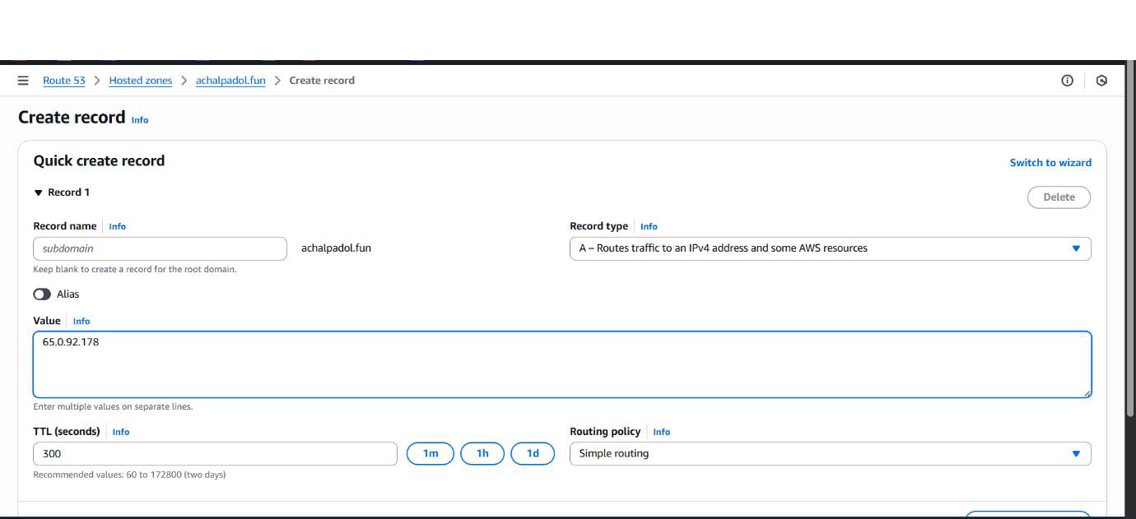
-Step 22: Now hit by using domain name.
